Project Proposal

# Introduction

An online learning platform will be implemented using the PHP programming language and CodeIgniter framework. The project will follow the Model-View-Controller (MVC) design architectural pattern and be deployed in my UQzone. Features of interest include the use of cookies and session to remember user and user being able to enrol in courses, add content to courses where they can also favorite content and add content to thier collection. Furthermore, users must be able to pay for their enrolment and update their personal information.

# Objectives

The goals of this project is to deliver an online learning platform that is easy to use and will be implemented by many learning platforms. Broadly speaking, desirable features include login/logout with cookies remembering user. Furthermore they include seeing courses with their uploaded content, user being able to upload content, favoriting uploaded content and adding content to their own collection. Lastly they should also be able to search, enroll and pay for courses as well as updating personal information. The timeline of the feature implementation is available in Appendix II and their UI/UX implementation is described under UI/UX design with mockups in Appendix I.

## Chosen technologies

**Client-side technologies:** Client-side technologies consist of PHP files with HTML, CSS and JavaScript languages. The jQuery library will be used for Javascript. This will enable more minimalist Javascript code, as well as simplifying both Ajax and HTML. Additionally, it comes with an API (Pedamkar, n.a.). The Bootstrap framework will also be used.

**Server-side technologies:** The server-side scripting language and framework implemented are PHP and CodeIgniter respectively. MySQL will be used as database.

**Adopted design pattern:**

The project will follow the Model-View-Controller (MVC) design architectural pattern as shown in figure 1.

Figure 1: Overview of the MVC model (Pop, 2014)

**Deploy the web in cloud:** The project will be deployed in my UQzone.

**Implement desirable features:** The features that will be implemented for each milestone are laid out under Appendix II as well as their difficulty level.

# UI/UX design

The user will first be met by a login page with the option of ‘remember me’. A faulty login will result in an error message while a successful one will lead the user to the ‘Home’ page. This page contains a notification stream of the different courses the user is enrolled in, and is empty if no courses have been chosen. That is to say, the user has to click on one of the courses they are enrolled in and the respective notification stream will become available underneath. On all content in the stream, the user has the possibility to comment, add to collection and favorite. Here, the user also has the option to upload new content under each course and add descriptions and tags. The scroll position of the html page is maintained as the client returns. Data is continuously loaded while the user scrolls.

The navigation (nav) bar is on the left, with the options (from top): ‘Home’, ‘Collection’, ‘Enrol’, ‘Pay’ and ‘My account’. Each page has a header, footer and nav bar. The second element in the bar, ‘Collection’, contains all content that they have added to collection. The third option in the nav bar is ‘Enrol’. Here students can use a search box autocompletion with filtering to search for courses, and then they can enrol in these courses. All enrolled courses can be seen under ‘Home’.

The fourth option is ‘Pay’, and here users will be able to use Online Payment Integration such as PayPal to pay for their courses. Once paid, they will also have the option of sending the receipt to their email as a pdf. In ‘My Account’, students can update their personal information. The email entered here is the one that will receive the receipt for paid courses.

The mockups can be seen in Appendix I. The mockups are also numbered with numbering corresponding to the features in Appendix II. The numbering of the features in Appendix II also gives the timeline of their implementation.

# Timeline

**First checkup (Proposal - 24th of March):** Delivery of project proposal and project deployed in UQ zone accessible at <https://infs3202-01c53ee7.uqcloud.net/project/login>.

**Second checkup (Milestone II - 21st of April):** Source code must be submitted. All core features to have been implemented. Implementation of features with a total of 20 points. These are available under Appendix II - Second checkup. The features are also nubmered so that this matches where the implementation will take in the mockups under Appendix I.

**Third checkup (Milestone III - 12th of May):** Implementation of additional features with a total of 20 points. Source code must be submitted. These are available under Appendix II - Third checkup. The features are also numbered so that this matches where the implementation will take in the mockups under Appendix I.

# References

Pop, D.-P., & Altar, A. (2014). Designing an MVC model for rapid web application development. Procedia Engineering, 69, 1172-1179.

Pedamkar, P. (n.a.). What is jQuery? Retrieved 15.03.2023 from <https://www.educba.com/what-is-jquery/>

# Appendix I

This appendix contains the mockups for UI/UX design. The yellow in the mockups demonstrate under which option in the nav bar the user is currently seeing. The numbering corresponds to the feature implementation seen in Appendix II. There are two subtitles, one for milestone I and for milestone II.

### Milestone I

#### Login page:

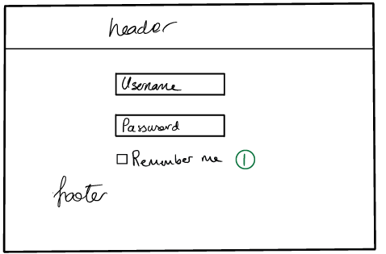

### 

### 

### Home page:

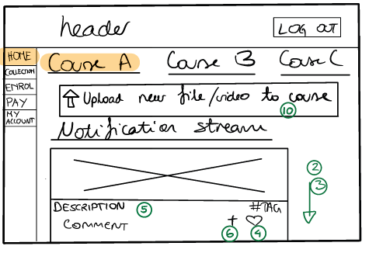

Collection page:

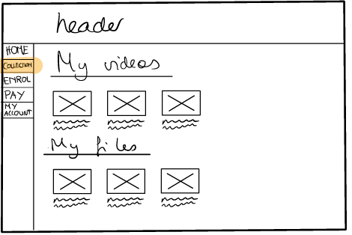

Enrol page:

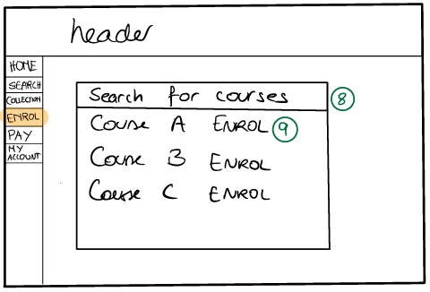

Pay page:

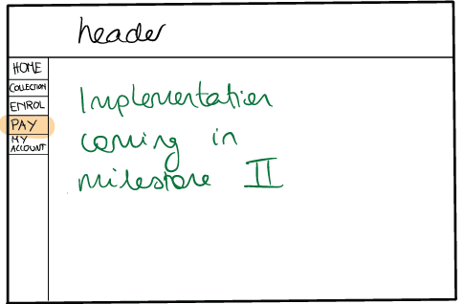

Account page:

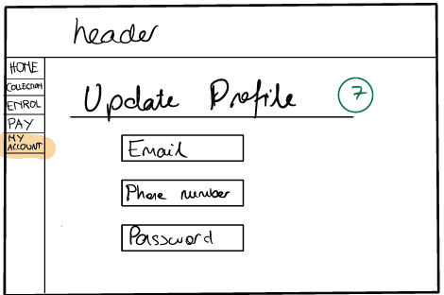

### 

### Milestone II

Home page:

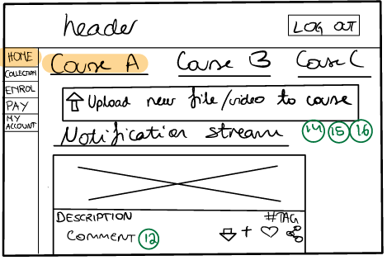

Pay page:

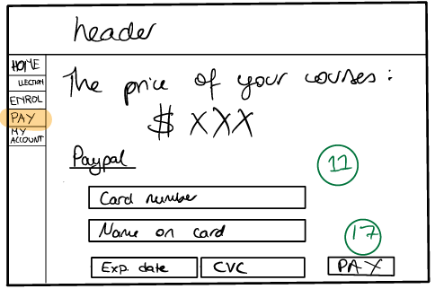

Account page:

### 

# Appendix II

### **Second checkup (Milestone II - 21st of April):**

Here follows a list of features that are to be implemented in this milestone.

##### Table 1:Basic features to be implemented along with numbering

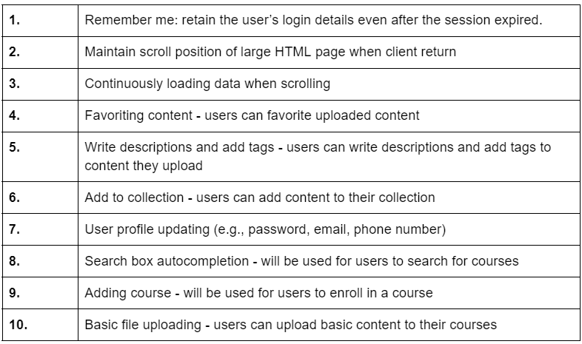

### 

### **Third checkup (Milestone III - 12th of May):**

Here follows a list of features that are to be implemented in this milestone.

##### Table 2: Basic and intermediate features to be implemented along with numbering

